Gardner Edwards Chemical Company

Thermal Process Group

Foreman’s Report



**Written by: Evan Tsiklidis**

**Group Members: Kristin Jones, Becky O’Toole, Nicole Thompson**

**I) Motivation**

The director of plant operations at the Gardner Edwards Chemical Company has requested for the thermal process group- Kristin Jones, Becky O’Toole, Nicole Thompson, and Evan Tsiklidis- to complete three tasks. The first task is to construct a heat exchange network and minimize the amount of cooling water that will be required. The second task will be to calculate the overall heat transfer coefficient, U, for each of the four heat exchangers that are available. The final task will be to add an additional heat exchanger to the network that can be used in the company’s styrene plant while optimizing its area to minimize the payback period.

**II) Theory**

1. **Introduction to Heat Transfer**

Chemical plants often require, and produce, reactant and product streams of varying temperatures. In order to promote certain reactions, ensure safety, and properly dispose of waste, heat exchangers are often required to cool hot streams and to heat cool streams. Exchanging heat between process streams will always be a preferable alternative to using steam or cooling water since the latter option will increase costs.

Shell and tube heat exchangers and plate and fame heat exchangers are two of the most commonly found heat exchangers found in industry. The interior design of a typical 4 tube-side pass heat exchanger can be seen in Figure 1.

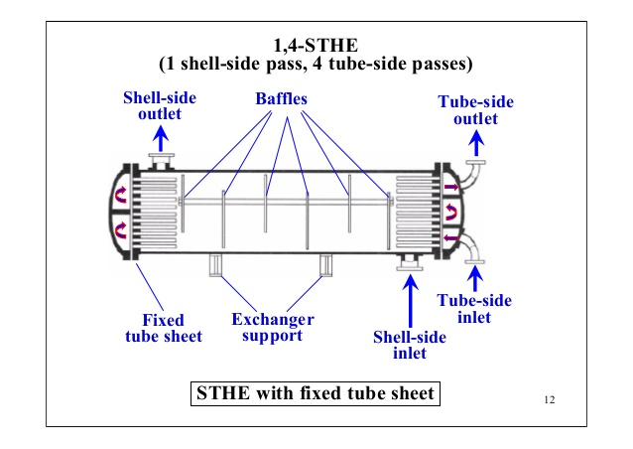

**Figure 1**: A 4 tube-side pass heat exchanger

*(Photo obtained from Dr. Patwardhan from Institute of Chemical Technology and is available at slideshare.net)*

The baffles that are found inside of a 4 tube-side pass heat exchanger promote heat transfer by increasing the amount of time that the fluid is kept in the heat exchanger. While this does increase the required pressure drop to drive the fluid through the heat exchanger, the mixture of counter flow, co-flow, and cross flow, the increase in the heat transfer is usually an acceptable tradeoff.

The governing heat transfer equation for a counter-flow exchanger can be derived to be

$$Q = U*A* ∆T_{lm} (1)$$

Where U is the overall heat transfer coefficient, A is the exposed surface area of the heat exchanger, and $∆T_{lm}$ is the log-mean temperature driving force for heat transfer. $∆T_{lm}$ can be calculated with equation (2) below

$$∆T_{lm}=\frac{{ (T}_{a1}-{ T}_{b2})-{ (T}_{a2}-{ T}_{b1}) }{ln⁡(\frac{{ (T}_{a1}-{ T}_{b2})}{{ (T}_{a2}-{ T}_{b1})})} (2)$$

Where each of the temperatures are defined in Figure 2.

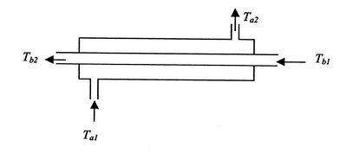

**Figure 2**: A countercurrent heat exchanger

*(Photo obtained from http://web.mit.edu/16.unified/www/FALL/thermodynamics/notes/node131.html)*

Unfortunately, a dimensionless correction factor, F, is often required to correctly determine the amount of heat transferred in the exchanger since the 4 tube-side heat exchanger that will be used is not completely counter-flow or concurrent-flow.

The plate and frame design is also used for many heat exchangers since they take up significantly less space than shell and tube exchangers and are composed of thin surfaces with large surface areas that ultimately promote heat transfer. The high turbulence created by the plate and frame design also creates a self-cleaning effect, which reduces fouling and increases the overall heat transfer coefficient. The interior design of a typical plate and frame heat exchanger can be seen in Figure 3 below.

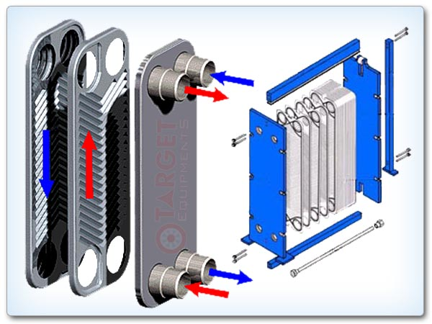

**Figure 3**: A plate and frame heat exchanger that can commonly be found in industry.

1. **The Overall Heat Transfer Coefficient**

Before the heat exchanger network can be finalized, the heat exchangers must be checked for fouling. An estimate for the overall heat transfer coefficient, U, can be determined from correlation, or from literature values, and then confirmed experimentally. EngineeringToolbox.com report that an approximate value for the heat exchange between two liquids being forced to flow would be about 1700 $\frac{W}{m^{2}*K}$.

The heat transfer coefficient can be verified experimentally by combining equation (1) with equation (3) below

$$Q = mc_{p}(T_{out}-T_{in}) (3)$$

If all of the heat exiting the hot stream enters the cold stream, then these two equations can be set equal to one another. Since all of the four terms present in equation (3) are known or can easily be determined with thermocouples, Q can be calculated directly. Since the areas, A, for all of the heat exchangers are known and $∆T_{lm}$ can easily be calculated with temperature data, equation (1) can be set equal to equation (3) and the overall heat transfer coefficient, U, can be calculated directly. This simple experiment will confirm results.

1. **Simulation of Heat Exchanger Network, 1**

Once all of the overall heat transfer coefficients have been calculated, the heat exchanger networks that minimize cooling water can be constructed. A heat exchanger network can be seen in Figure 4 below.

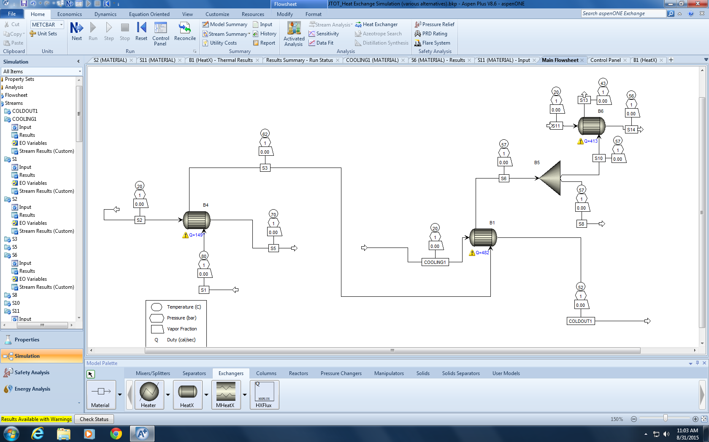

**Figure 4:** A heat exchanger system of the first network that will be constructed.

This simulation splits the feed before it ever enters a heat exchanger. One of the two cooling streams is used to cool 3.3 $\frac{L}{min}$ to 40°C. This heats the cooling water, but it is still cool enough to use as cooling water for a second heat exchanger. Therefore, two shell and tube heat exchangers are used to cool the remaining stream to 55°C.

1. **Simulation of Heat Exchanger Network, 2**

Once the overall heat transfer coefficient has been calculated, the heat exchanger network that minimizes cooling water can be constructed. A heat exchanger network Aspen simulation was attached. In the simulation, 2.5 $\frac{L}{min}$ of 20°C cooling water enters a plate and frame heat exchanger and cools the hot, process stream down to 55°C. The cooling water absorbs the heat released and its temperature rises to 58°C. A splitter is then used to divide the 56°C process stream into two streams; 3.3 $\frac{L}{min}$ will enter a second 4 tube-side pass heat exchanger and will be cooled down to 40°C. According to the Aspen simulation, this will only require 1 $\frac{L}{min}$ of the 20°C cooling water.

According to the Aspen simulation, this will only require a total of 3.5 $\frac{L}{min}$ of cooling water, which is likely an acceptably small flow rate. Figure 5 below is an illustration of the first network that will be performed.

**Key**















1. 

**: Cooling water**

**: Plate and Frame**

**: Shell and Tube**

**: 80°C Steam**

**: Heated Cold Stream**

**: 55°C Steam**

**: 55°C Product Steam**

**: 40°C Product Steam**

**Figure 5:** A schematic of the first network that will be constructed

1. **Simulation of Heat Exchanger Network, 3**

Another possible configuration would be to split the process feed before it enters either of the heat exchangers. The plate and frame heat exchanger can cool one of the product streams to 40°C while the shell and tube heat exchanger can cool the second product stream to 55°C.A simulation in Aspen of the described network could not be run because access to Aspen has not been given to the group at this time. A schematic of the simulation can be found in Figure 6.

**: Cooling water**

**: Plate and Frame**

**: Shell and Tube**

**: 80°C Steam**

**: Heated Cold Stream**

**: 55°C Steam**

**: 55°C Product Steam**

**: 40°C Product Steam**

**Key**















1. 



**Figure 6:** A schematic of the second network that will be constructed; the spilt occurs before it enters the heat exchangers.

**III) Experimental Plan**

1. **Explicit Team Member Assignments**

Kristin will be assigned the role of ensuring that all of the thermocouples are connected properly and that the LabVIEW program is properly acquiring the necessary data. There are eight thermocouples available for use, it will be her responsibility to ensure that they are connected at the proper locations and that the LabVIEW program is recording the data to the proper place. She will also be responsible for taking the data and inputting it into the attached spreadsheet, which has been written to calculate the overall heat transfer coefficient for each of the heat exchangers. This must be done during the experiment to ensure that the data that we are acquiring makes physical sense and is not a victim of an unnecessary error. Becky will be assigned the task of ensuring that the specified flow rates are being met; this is precisely specified in ‘Part C) Determination of Flow Rates’ of this section. Once this is complete, she will also be responsible for measuring the overall heat transfer coefficient for each of the heat exchangers; this is described in more detail in ‘Part B) Startup Procedure and Determination of Overall Heat Transfer Coefficients’ of this report. Nicole will be assigned the task of setting up each of the networks described in Section II of this report. Evan will be given a managerial role and will overlook each of the other three group members to ensure that all of their tasks are being performed correctly and to provide assistance if needed.

1. **Startup Procedure and Determination of Overall Heat Transfer Coefficients**

Before the heat exchange network can be properly assembled, all 4 group members must know how to fit the insulated pipes into the proper fittings; this will help to prevent leaks and avoid burns. There will be 8 thermocouples available to the group, which means that the overall heat transfer coefficient can be experimentally determined for two heat exchangers at one time. All group members will put on insulated gloves and before touching any of the metal from this point forward.

1. Nicole, with insulated gloves, will connect the pipe that contains the steam and the pipe that contains the cooling water to the heat exchange unit.
2. A metal tube will then be directed towards the drain to dispose of the condensed steam. This can be in seen in Figure 7 below.

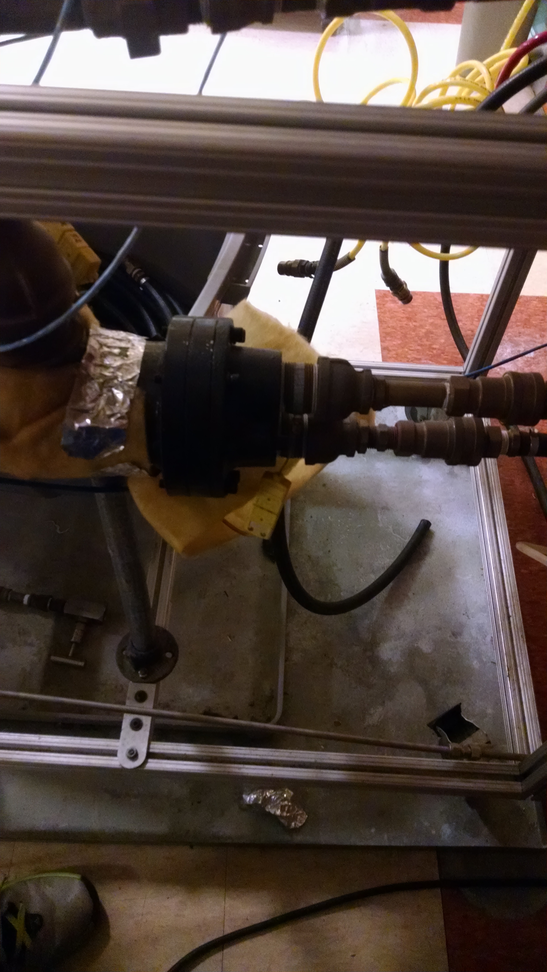

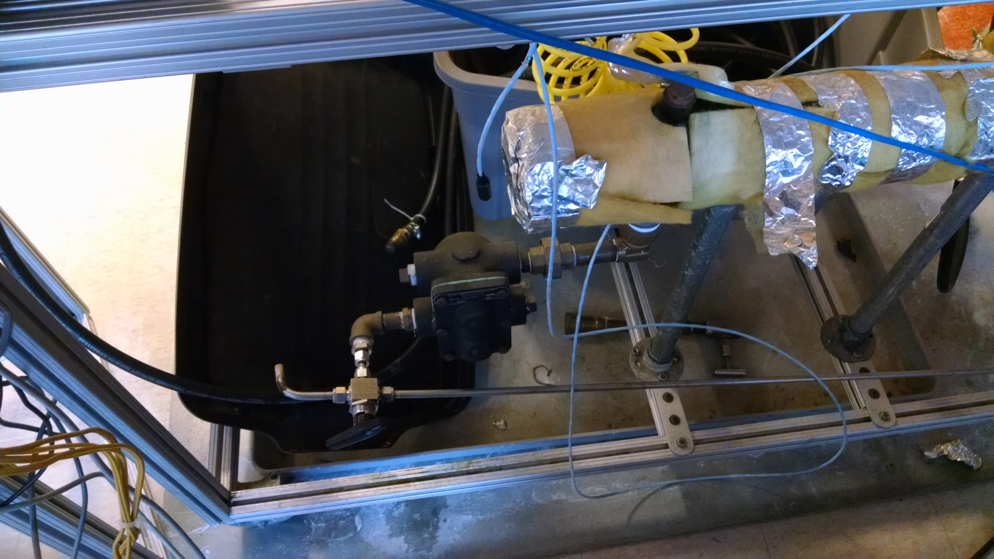

**Figure 7:** Heat exchanger unit to heat stream to 80°C and metal tube to funnel the condensed steam to drain.

1. Nicole will then connect the insulated pipes with proper fittings that carry the 80°C process stream and the 20°C cooling water to one of the four heat exchangers.
2. She will configure plate and frame exchanger in the countercurrent flow setup, where the hot stream will exit from the terminal diagonally across from it.
3. Kristin will connect the thermocouples to the inlet and outlet ports of the heat exchangers to measure their temperature; they will be connected to National Instruments Elvis II device to record the temperature. She will then use the corresponding LabVIEW software to acquire the temperature data. The thermocouple system and the LabVIEW program can be seen in Figure 8 below.

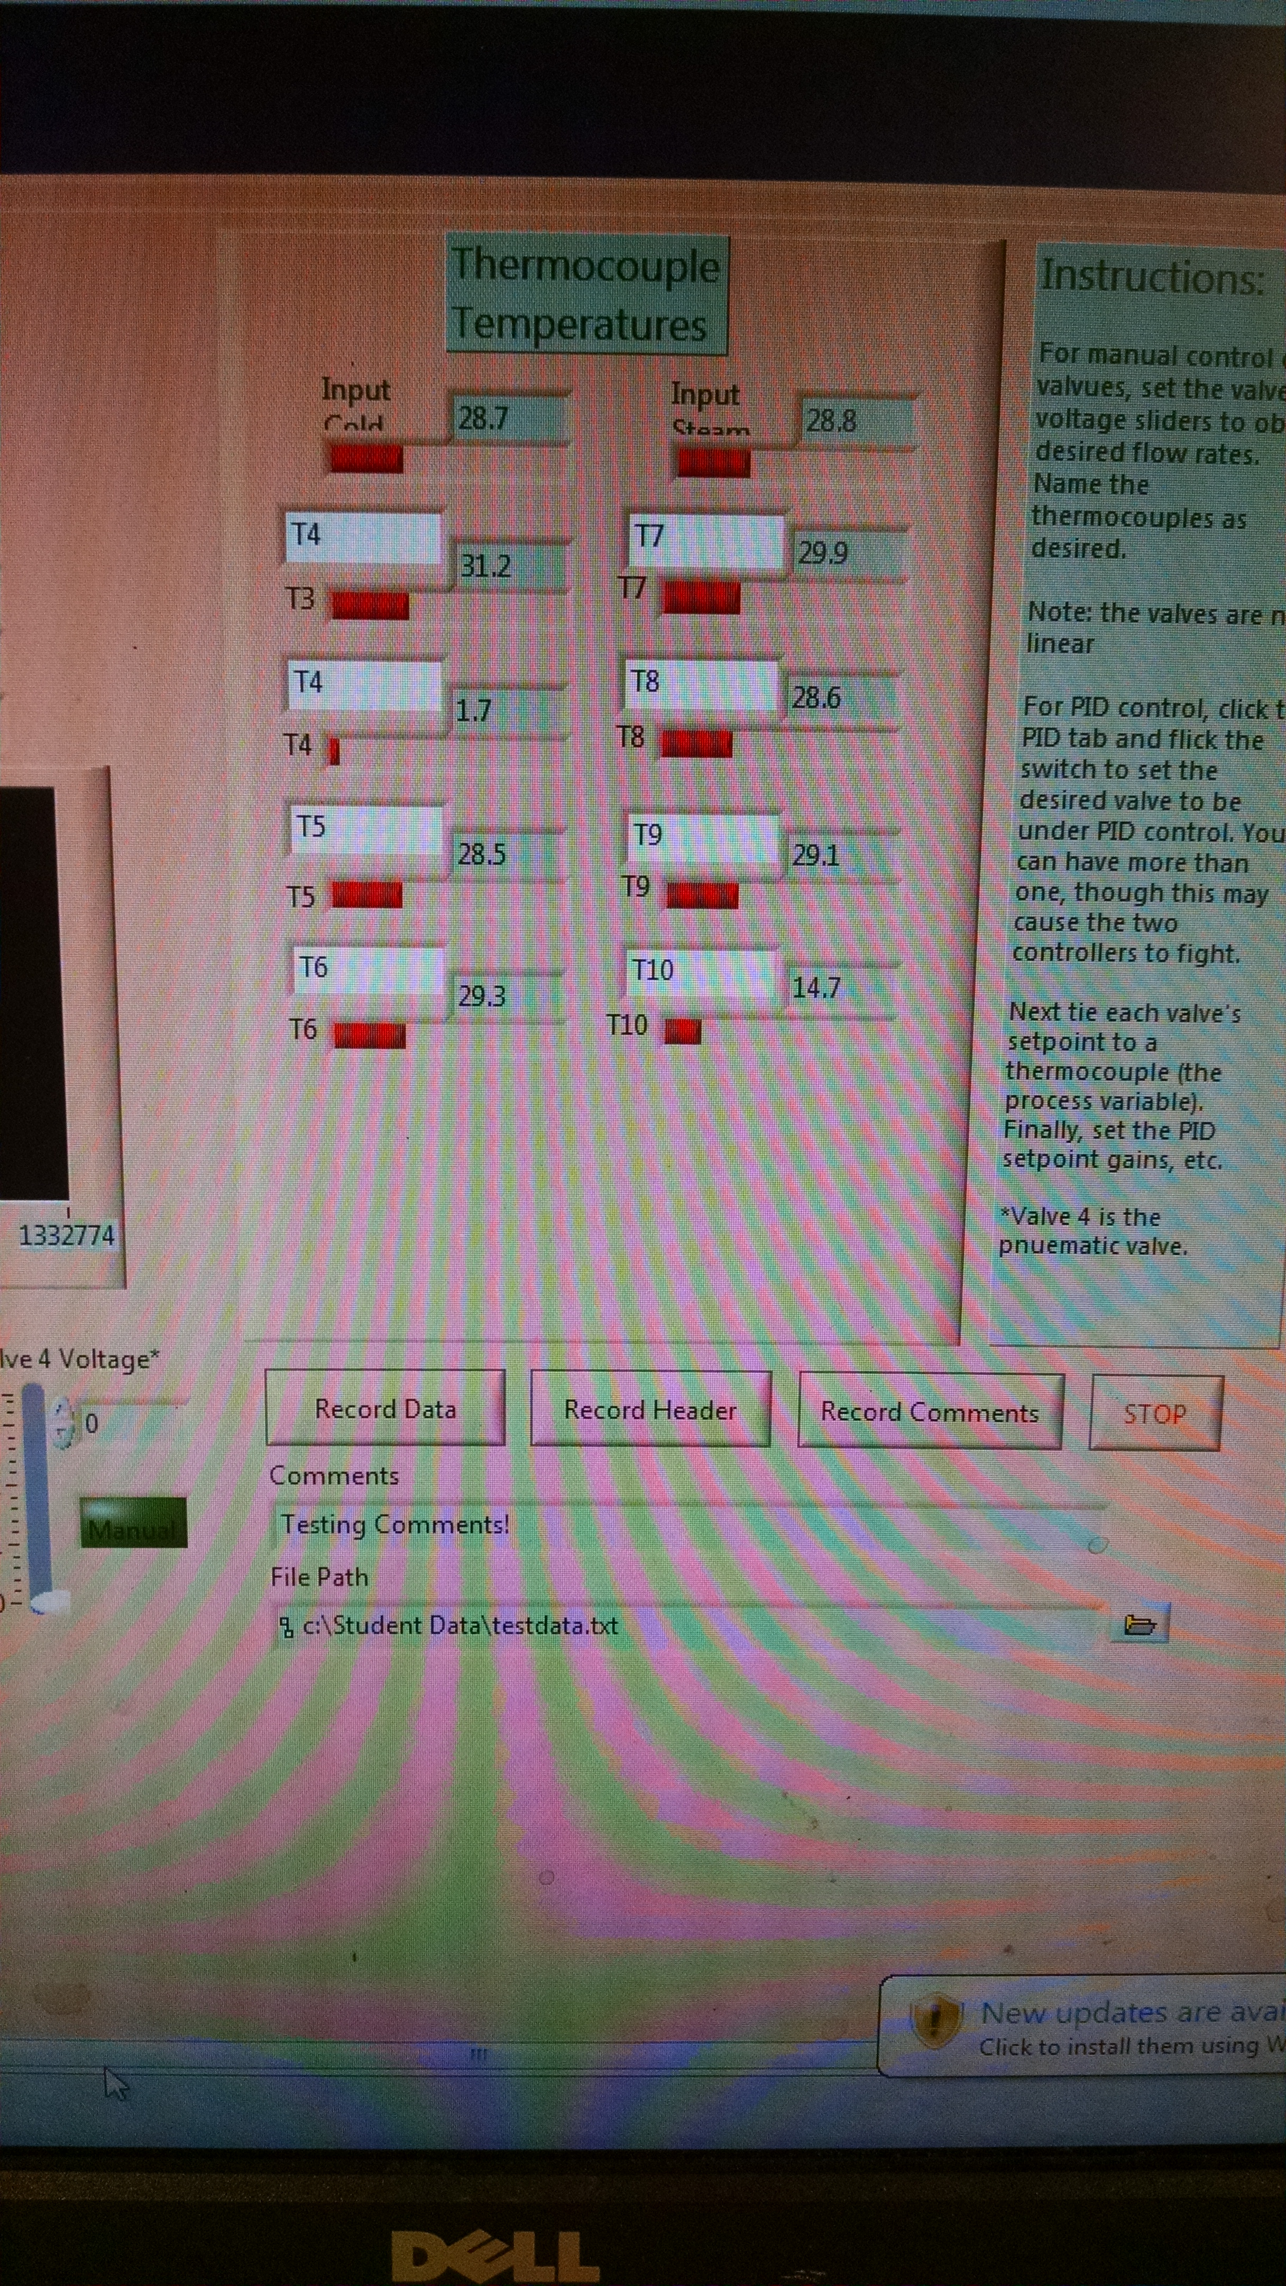

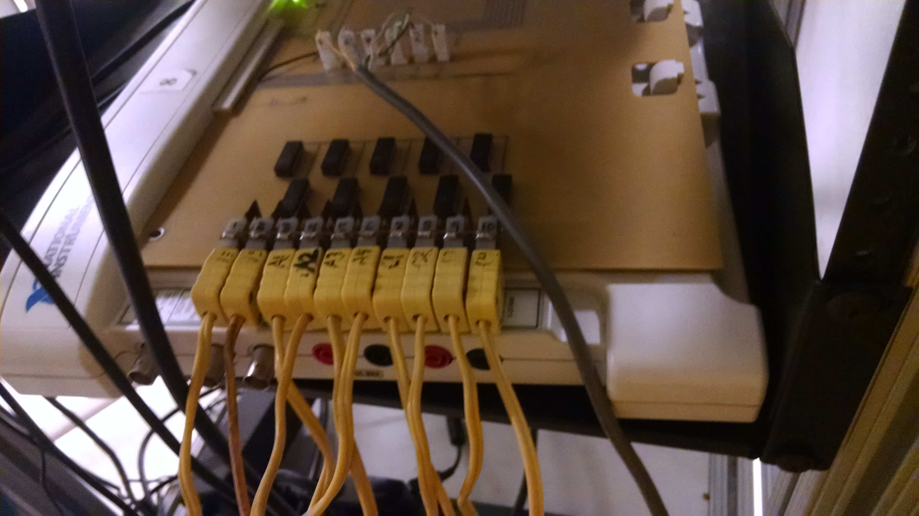

**Figure 8**: LabVIEW software and thermocouples to measure and record temperature and flow rate data.

1. This task will be performed for each of the four heat exchangers.
2. Kristin and Evan will input the data obtained into the attached excel spreadsheet that has been programmed to calculate the overall heat transfer coefficient for each of the four heat exchangers.
3. These small experiments may be repeated to validate whether the acquired data agrees with the background theory and makes physical sense. A sample of the calculations being performed by the excel spreadsheet can be found in the appendix of this report.
4. **Determination of Flow Rates**

Before the networks can be created, the valves must be closed enough to guarantee that the specified flow rates are being met.

1. Becky will connect the hot process stream that was obtained from Part B to the globe valve and adjust the valve to ensure that the flowrate is the required 5.3 $\frac{L}{min}$. This valve will not be adjusted for the duration of the experiment to ensure that the process stream remains at 5.3 $\frac{L}{min}$.
2. After the process stream is cooled to 55°C, it must be split into a 3.3 $\frac{L}{min}$ stream and a 2.0 $\frac{L}{min}$ stream. Becky will, again, allow the hot process stream to flow through the two remaining globe valves and adjust the valve accordingly to ensure that the flow rates of the two streams meet the specifications. An image of the globe valves available to us can be seen in Figure 8 below.
3. **Constructing the Networks**

Three networks will be constructed in an attempt to determine which one will minimize the flow rate of the cooling water.

1. All of the valves will be closed.
2. Nicole will connect the insulated pipes that will carry the hot stream and the cold stream to the plate and frame heat exchanger.
3. She will then connect the exiting streams to the input of the proceeding heat exchanger.
4. She will construct all of the networks described in the Theory section with all of the valves closed. All of the pipes that carry waste will be directed towards the drain.
5. She will then put the insulated gloves on and carefully open the valves for the steam and the cooling water. If any leak is detected, she will immediately close the valves and secure the area of the leak.
6. Once Nicole checks to make sure that there are no major leaks, she will open the valve for the steam and for the cooling water and wait for the system to reach steady state.
7. Once the temperatures recorded by the thermocouples stop changing significantly, Kristin will record the temperature and flow rate data with the LabVIEW program.
8. Before the next network can be constructed, all of the valves will be closed to stop the flow of the fluids.

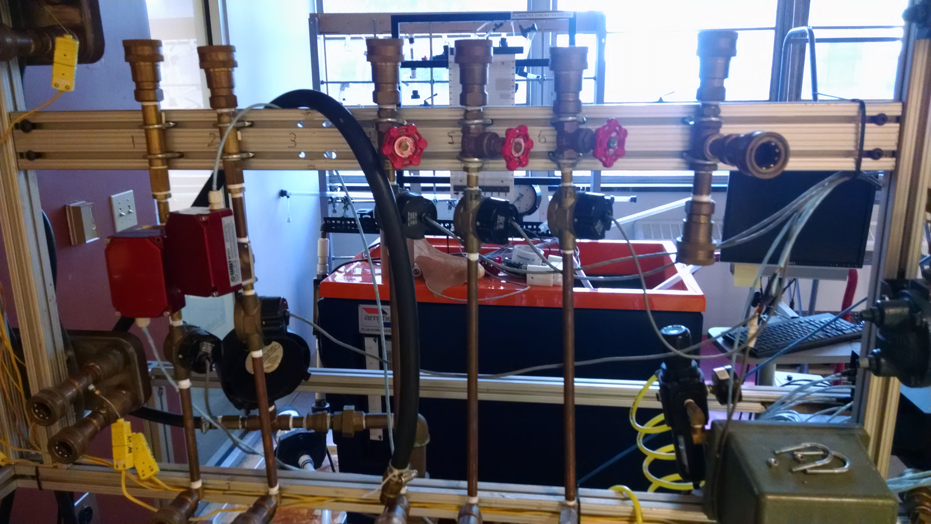

**Figure 9:** Gate valves that will be used to control flow rates of streams.

**IV) Safety Procedure**

1. **Leaks**

The thermal process group is very well aware that handling of heat exchanger equipment can be dangerous if the proper precautions are not taken. One of the biggest safety concerns would be the temperature of the hot streams, which can range from 40°C to 150°C. In order to minimize the risk of burns, the heat exchange network will be composed of insulated tubes with proper fittings to carry the water. All streams will lead into the drain that is present directly below the valve that releases the steam. If a minor leak is detected, it must be reported immediately and an executive decision by Evan Tsiklidis must be made to decide whether the experiment can proceed as planned. A minor leak will be handled by positioning the source of the leak above a receptacle that can catch the leaking water. If a major leak is detected, all four group members are aware that it must be reported so that the entire system can be shut down immediately.

1. **Proper Attire**

In order to reduce the risk of hot water coming in contact with skin or eyes, all four group members must wear safety goggles and lab coats at all times during the experiment. They must also come to the lab wearing close-toed shoes and long pants to prevent the water from splashing on their bare skin.

1. **Fire Procedure**

With four different experiments being performed in the lab, there is the possibility of a fire. In the event of a fire, all four group members will immediately evacuate the lab from one of the three exits and pull the fire alarm located outside of the room. Only in the event that a person is trapped by the fire will a fire extinguisher be used to put out the flames.

**V) Appendix**

**Excel Spreadsheet Overall Heat Transfer Coefficient Sample Calculation**

In the plate and frame heat exchanger, the flow can be modeled as countercurrent flow. In order to calculate the overall heat transfer coefficient, the heat lost from the hot process stream must be equated to the transport equation for countercurrent flow.

$$Q = \dot{m}c_{p}\left(T_{out}-T_{in}\right)= U_{o}A∆T_{lm}$$

The density of water is 1 $\frac{kg}{L}$, the heat capacity of water is 4.18 $\frac{kJ}{kg*K}$, the area of the heat exchanger is 0.28 m2, and the temperatures given in the figure 3, the overall heat transfer coefficient can be calculated to be 785 $\frac{W}{m^{2}*K}$ (The numbers chosen were example numbers and are not a true calculation of the overall heat transfer coefficient).

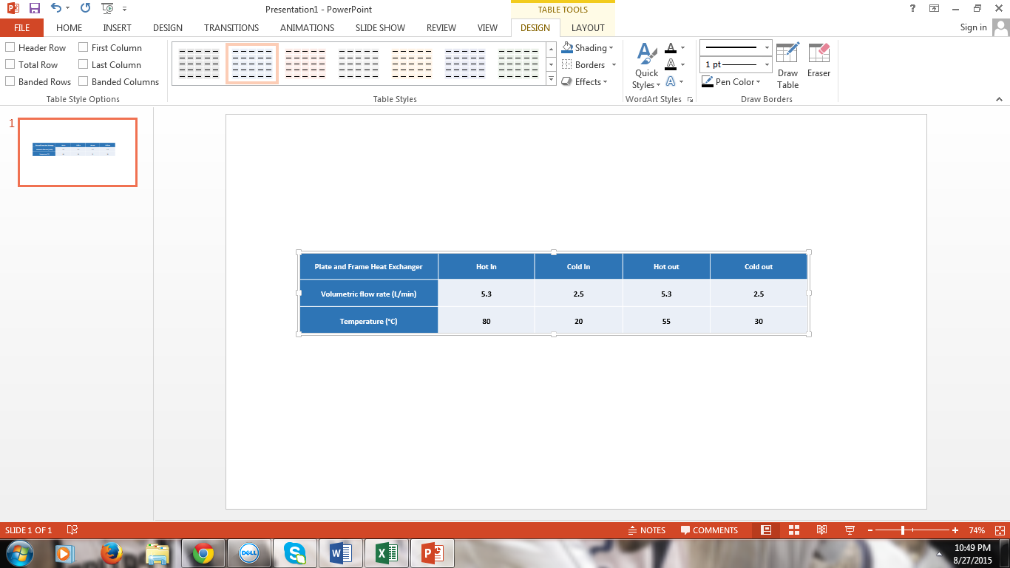

**Figure 10:** Summary of the four streams in the plate and frame heat exchangers.